Chapter 7, Problem 12.

Using Fig. 7.92, design a problem to help other students better understand source-free RL circuits.
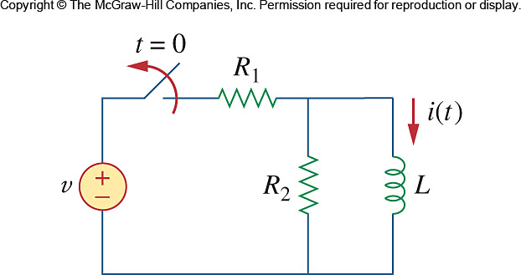

Figure 7.92
For Prob. 7.12.

